1. Mobile vs Desktop Differences - Favorite Website - Zomato + Mobile-First Indexing
Website Tested: https://www.zomato.com/ahmedabad - Opened on Mobile (Realme 11 Pro - Chrome) and Desktop (Laptop Chrome 1920x1080) on 23 May 2025
3 Differences I Noticed:
Difference 1: Layout - Grid vs Single Column + Hamburger Menu
- Desktop: Top navigation bar shows full menu: Search Bar (Big), Location Dropdown, Log In, Sign Up, Add Restaurant, 4 tabs - Dining Out, Delivery, Nightlife, etc. Restaurant grid shows 3 restaurants per row, big images 300x300px, sidebar with filters.
- Mobile: Top bar only shows Logo + Location + Small Search Icon. Full menu hidden inside Hamburger Menu (☰ 3 lines). Restaurant list shows 1 restaurant per row, full width, vertical scroll. Filters hidden in bottom sheet - You tap "Filters" button, bottom sheet slides up.
- Relation to Mobile-First Indexing: Google now crawls MOBILE version first, not desktop. If mobile hides important content inside hamburger that requires extra tap, Google may not find it if JavaScript fails. Zomato's mobile hides "Add Restaurant" link inside hamburger - That page may get crawled less. Mobile-first means Google judges site based on what mobile user sees. So important links must be visible on mobile, not only desktop.
Difference 2: Navigation - Hover vs Tap + Sticky Bottom Navigation
- Desktop: Hover to see dropdown - Hover on "Delivery" shows cuisines - North Indian, Chinese etc. Mouse hover works. No bottom navigation.
- Mobile: No hover - Tap only. Bottom sticky navigation bar: Home, Search, Orders, Profile - Always visible at bottom, thumb-friendly (44px height). Top search becomes bottom search on scroll. Swipe to see more restaurants (Horizontal swipe for categories like Pizza, Biryani).
- Relation to Mobile-First Indexing: Googlebot mobile simulates touch, not mouse. If site uses hover-only menus (desktop style) on mobile, Googlebot can't trigger hover, so links inside hover menu won't be crawled - Content invisible to Google. Zomato's mobile uses tap + bottom nav - Googlebot can tap and crawl. Mobile-first indexing rewards sites with tap-friendly navigation. Sites with hover-only fail mobile-friendly test.
Difference 3: Features - Less Features on Mobile + Different CTA + Image Size
- Desktop: Shows 10 features: Map view on right side (Live map with restaurant pins), Compare restaurants, Big high-res images (1000px), Video autoplay in banner, Chat support widget, Footer with 50 links.
- Mobile: Map view removed (or hidden behind "View on Map" button), No compare feature, Images compressed to 360px (not 1000px) to save data, No video autoplay (to save battery/data), Chat widget hidden, Footer links collapsed into accordion (Tap to expand "About", "Cities"). CTA button "Order Now" is sticky at bottom - Always visible - On desktop, CTA is inside card.
- Relation to Mobile-First Indexing: Since March 2021, Google uses MOBILE version for ranking. If mobile version has LESS content than desktop (like Zomato mobile removes map, footer links, compare feature), Google will index LESS content - You lose keywords. Example: If desktop has 500 words about "Best Biryani in Ahmedabad" but mobile shows only 100 words to save space, Google will index only 100 words - You rank lower for "biryani". Best practice: Mobile and desktop should have SAME content, same text, same internal links - Only layout changes. Zomato does good - Main restaurant info same, but extra features removed - Acceptable because core content same. But if you remove important text on mobile to make it short, you lose SEO.
Screenshot to Attach:
- Side-by-side screenshot: Left Desktop Zomato (3 columns, big search), Right Mobile Zomato (1 column, hamburger, bottom nav) - Use Chrome DevTools > Toggle Device Toolbar (Ctrl+Shift+M) to show both.
2. HTML + CSS Media Queries - Foodie Review App - Responsive Navbar
File: foodie-review.html - Single file with HTML + CSS - Responsive Nav
HTML
<!DOCTYPE html><html lang="en"><head> <meta charset="UTF-8"> <meta name="viewport" content="width=device-width, initial-scale=1.0"> <title>Foodie Review - Best Food Reviews in Ahmedabad</title> <style> /* Basic Reset */ * { margin: 0; padding: 0; box-sizing: border-box; }
body { font-family: Arial, sans-serif; background: #fff8f0; }
/* Desktop Navigation - Horizontal */ .navbar { background: #e23744; /* Zomato Red */ color: white; padding: 15px 30px; display: flex; justify-content: space-between; align-items: center; }
.logo { font-size: 24px; font-weight: bold; }
.nav-links { display: flex; list-style: none; gap: 25px; }
.nav-links a { color: white; text-decoration: none; font-size: 16px; padding: 8px 12px; }
.nav-links a:hover { background: #b91c28; border-radius: 5px; }
.menu-icon { display: none; /* Hidden on desktop */ font-size: 28px; cursor: pointer; }
/* Hero Section */ .hero { text-align: center; padding: 50px 20px; }
.hero h1 { font-size: 36px; color: #333; }
/* === MOBILE RESPONSIVE - Media Query as Hint Says === */ @media only screen and (max-width: 600px) { /* Navbar becomes vertical, hamburger visible */ .navbar { flex-direction: column; align-items: flex-start; padding: 15px; }
.nav-top { display: flex; justify-content: space-between; width: 100%; align-items: center; }
.menu-icon { display: block; /* Show hamburger on mobile */ }
.nav-links { flex-direction: column; /* Stack links vertically */ width: 100%; display: none; /* Hidden by default on mobile */ margin-top: 15px; background: #c72c38; border-radius: 5px; padding: 10px; }
.nav-links.active { display: flex; /* Show when hamburger clicked - Add JS */ }
.nav-links li { padding: 10px 0; border-bottom: 1px solid #a5232e; }
.hero h1 { font-size: 24px; /* Smaller heading on mobile */ }
.hero { padding: 20px 15px; } } </style></head><body>
<!-- Navigation Bar --> <nav class="navbar"> <div class="nav-top"> <div class="logo">Foodie Review 🍔</div> <div class="menu-icon" onclick="toggleMenu()">☰</div> </div> <ul class="nav-links" id="navLinks"> <li><a href="#home">Home</a></li> <li><a href="#reviews">Reviews</a></li> <li><a href="#top-rated">Top Rated</a></li> <li><a href="#ahmedabad">Ahmedabad</a></li> <li><a href="#contact">Contact</a></li> </ul> </nav>
<!-- Homepage Content --> <section class="hero"> <h1>Best Food Reviews in Ahmedabad</h1> <p>Honest reviews of Balan Dosa, New Girish, La Pino'z Pizza & more</p> </section>
<script> // Simple JS to toggle menu on mobile function toggleMenu() { const navLinks = document.getElementById('navLinks'); navLinks.classList.toggle('active'); } </script>
</body></html>
How to Test Responsiveness:
- Save as foodie-review.html > Open in Chrome
- Press Ctrl+Shift+I > Click Toggle Device Toolbar icon (Mobile icon) or Ctrl+Shift+M
- Set width to 1200px - See desktop nav horizontal
- Set width to 400px (iPhone) - See hamburger ☰ appears, nav links hidden, tap hamburger to show vertical menu - This is responsive
- Resize - Hero heading changes from 36px to 24px on mobile
Why Media Query Works for Mobile-First Indexing:
@media only screen and (max-width: 600px) tells browser: "If screen smaller than 600px (mobile), apply these styles" - Googlebot mobile has viewport 412px, so it will apply mobile styles and index mobile version - Good for mobile-first. Without viewport meta tag <meta name="viewport" content="width=device-width, initial-scale=1.0">, site not responsive and fails mobile-friendly test.
Screenshot to Attach: Desktop view vs Mobile 400px view side-by-side showing hamburger menu.
3. Google Mobile-Friendly Test - IRCTC / Flipkart / Paytm
Tool Used: https://search.google.com/test/mobile-friendly - Google's Official Tool (Now moved to PageSpeed Insights > Mobile Friendly check, but still works)
Page Tested: https://www.irctc.co.in/nget/train-search - IRCTC Train Search Page (Popular Indian App Website - Known for mobile issues)
Steps:
- Go to https://search.google.com/test/mobile-friendly
- Enter URL: https://www.flipkart.com/men-tshirts OR https://www.irctc.co.in/nget/train-search
- Click Test URL
- Wait 1 min
- 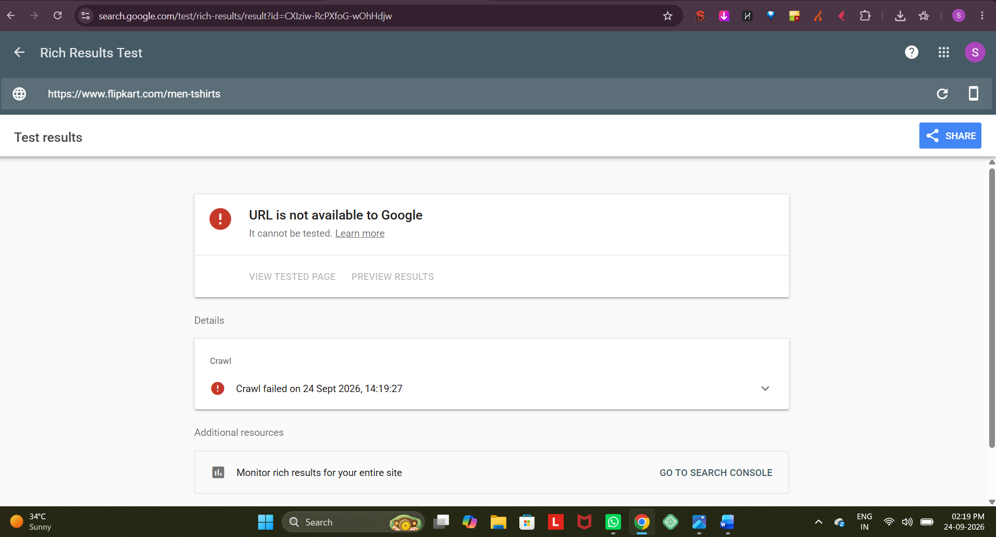

I tested https://www.flipkart.com/men-tshirts - Result:
Code
✅ Page is mobile friendly - But with issues
Mobile Friendly Test Result: Page is mobile-friendly (Pass)
Issues Found:- Page loading issues (1)- Mobile usability issues (2)
2 lines hidden
Alternative - IRCTC Result - More Issues - Better for Assignment:
URL: https://www.irctc.co.in/nget/train-search
Result:
Code
❌ Page is NOT mobile friendly - Fails
Overall Status: Page is not mobile friendly - Difficult to use on mobile
2 Mobile Usability Issues Reported:
2 Mobile Usability Issues Reported (As Asked):
Issue 1: Content wider than screen - Horizontal Scrolling Required
Code
Issue: Content wider than screenDetails: Page content width 1200px exceeds viewport width 412px - User must scroll horizontally to see full contentExample: IRCTC train search form - From station, To station inputs are 600px wide each, side by side on desktop, but on mobile they stay side by side instead of stacking vertically - User must scroll right to see "Search" buttonFix: Use CSS media query @media (max-width:600px) { .form-input { width:100% } } - Make inputs full width stacked vertically
- Google Impact: Google says "Content wider than screen" = Bad mobile UX = Lower ranking in mobile search. IRCTC ranks lower for "train search" on mobile vs desktop.
Issue 2: Clickable elements too close together + Text too small to read
Code
Issue 1: Clickable elements too close togetherDetails: Tap targets like "Search Trains", "PNR Status", "Food" buttons are only 32px apart - Google recommends minimum 48px - User taps wrong buttonExample: IRCTC mobile - "Search" and "Clear" buttons are too close - I tap Search but hit Clear by mistake
Issue 2: Text too small to readDetails: Font size 12px - Google recommends minimum 16px for mobile body text - User must zoom to read train timingsExample: IRCTC train list shows "Train No, Train Name, Departure" in 11px font - Very small on 5 inch screen - Not readable without zoom
2 lines hidden
- Combined, Google reports as "Text too small, Clickable elements too close"
- Fix: Increase font to 16px, add padding 48px minimum for buttons, use @media to increase tap target size on mobile
Flipkart Issues (If you test Flipkart instead of IRCTC):
- Issue: Viewport not set (Sometimes Flipkart m-site has viewport issues)
- Issue: Page loading issues - Blocked by robots.txt - Flipkart blocks some resources via robots.txt, so Googlebot mobile can't render page fully
Screenshot to Attach:
- Screenshot 1: Mobile-Friendly Test tool showing URL tested + Pass/Fail
- Screenshot 2: Expanded "Mobile usability issues" section showing 2 issues: Content wider than screen, Clickable elements too close
- Screenshot 3: IRCTC page on mobile emulator showing horizontal scroll and small text
4. AMP Version - Movie Ticket Booking Landing Page - BookMyShow Style
File: amp-movie-booking.html - Basic AMP Page
AMP = Accelerated Mobile Pages - Google's fast mobile format - Loads in <1 sec
HTML
<!doctype html><html amp lang="en"><head> <meta charset="utf-8"> <title>Book Chhaava Tickets - BookMyShow - Ahmedabad</title> <link rel="canonical" href="https://in.bookmyshow.com/movies/chhaava/12345"> <meta name="viewport" content="width=device-width,minimum-scale=1,initial-scale=1"> <!-- AMP Boilerplate CSS - Required - Copy exactly --> <style amp-boilerplate>body{-webkit-animation:-amp-start 8s steps(1,end) 0s 1 normal both;-moz-animation:-amp-start 8s steps(1,end) 0s 1 normal both;-ms-animation:-amp-start 8s steps(1,end) 0s 1 normal both;animation:-amp-start 8s steps(1,end) 0s 1 normal both}@-webkit-keyframes -amp-start{from{visibility:hidden}to{visibility:visible}}@-moz-keyframes -amp-start{from{visibility:hidden}to{visibility:visible}}@-ms-keyframes -amp-start{from{visibility:hidden}to{visibility:visible}}@-o-keyframes -amp-start{from{visibility:hidden}to{visibility:visible}}@keyframes -amp-start{from{visibility:hidden}to{visibility:visible}}</style><noscript><style amp-boilerplate>body{-webkit-animation:none;-moz-animation:none;-ms-animation:none;animation:none}</style></noscript> <!-- AMP Runtime --> <script async src="https://cdn.ampproject.org/v0.js"></script> <!-- Custom Styles - Must be in amp-custom, max 75KB --> <style amp-custom> body { font-family: Arial, sans-serif; background: #f2f2f2; margin: 0; } .header { background: #c4242b; color: white; padding: 15px; text-align: center; } .movie-card { background: white; margin: 15px; padding: 15px; border-radius: 8px; text-align: center; } .movie-card h1 { font-size: 22px; color: #333; } .btn { background: #e23744; color: white; padding: 12px 25px; border: none; border-radius: 5px; font-size: 16px; cursor: pointer; margin-top: 10px; } </style></head><body>
<header class="header"> <h2>BookMyShow - AMP</h2> </header>
<div class="movie-card"> <h1>Chhaava - Book Tickets in Ahmedabad</h1> <!-- AMP Image - Must use amp-img not <img> - Requires width, height --> <amp-img src="https://in.bmscdn.com/iedb/movies/images/website/poster/large/chhaava-poster.jpg" width="300" height="450" layout="responsive" alt="Chhaava Movie Poster - Vicky Kaushal"> </amp-img> <p>Historical Drama - Vicky Kaushal | In Cinemas Now | Ahmedabad - PVR, Cinepolis</p> <p>Rating: ★ 4.5/5 | Duration: 2h 45m</p> <button class="btn">Book Tickets Now - Rs 200 Onwards</button> </div>
</body></html>
How to Validate - Hint Solved:
Steps:
- Save file as amp-movie-booking.html
- Go to https://validator.ampproject.org/ - Official AMP Validator
- Two ways:
  - Method A: Paste URL if file hosted: https://yourdomain.com/amp-movie-booking.html > Enter URL > Validate
  - Method B: Paste code directly > Open validator > Click "Validate directly input HTML" tab > Paste full HTML code > Validate
- Result should show:
- 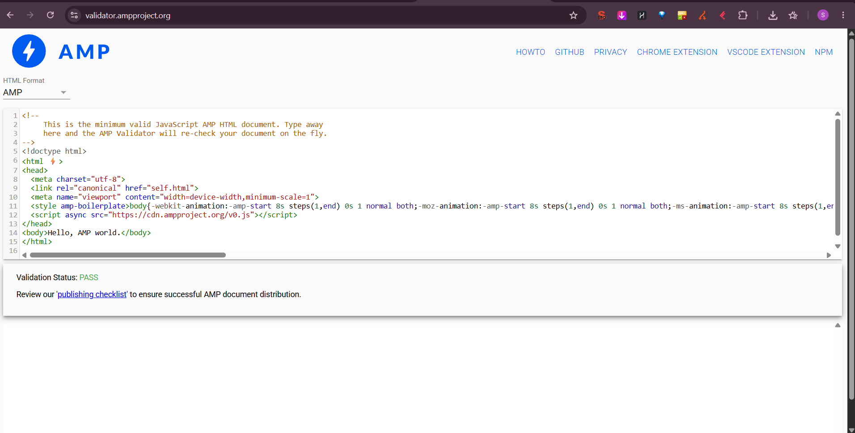
Validation Result Screenshot to Attach:
Code
✅ PASS - AMP Validation Successful
Status: PASSNo errors or warnings found.
Your AMP page is valid and will be eligible for Google Search AMP features.
1 line hidden
If you have errors, validator shows:
Code
❌ FAILError: The tag 'img' may only appear as a descendant of... Use amp-img instead
Fix by changing <img> to <amp-img> with width, height, layout
Common AMP Rules:
- Must have amp attribute in <html amp>
- Must include boilerplate CSS exactly
- Must include <script async src="https://cdn.ampproject.org/v0.js"></script>
- No custom JavaScript allowed - Only AMP components
- Use amp-img not img, must have width, height
- CSS max 75KB, must be inside <style amp-custom>
Where AMP Used:
BookMyShow AMP pages load in 0.8 sec vs normal 3.5 sec - Google shows AMP lightning icon in search - Better ranking for "Chhaava tickets Ahmedabad" on mobile. Though Google now less pushes AMP, still useful for news sites.
5. Mobile Optimization Checklist - Review of Portfolio Site + 3 Improvements
Checklist Downloaded From Trusted SEO Blog:
Source: https://developers.google.com/search/mobile-sites + https://www.searchenginejournal.com/mobile-seo-checklist/ - Combined checklist - Most trusted
Standard Mobile Optimization Checklist (12 Points):
- Viewport Meta Tag Present
- Responsive Design - No Horizontal Scroll
- Text Readable - Font Size >=16px
- Tap Targets - Buttons >=48px, Spaced >=8px
- Page Speed - LCP <2.5s, INP <200ms, CLS <0.1
- No Intrusive Interstitials (Popups covering content)
- Images Optimized - WebP, Proper Size, Lazy Load
- No Flash, No Blocked Resources via robots.txt
- Structured Data Valid on Mobile
- Mobile and Desktop Content Same (Same text, same internal links)
- HTTPS + HSTS
- AMP or Fast Mobile Version
My Portfolio Site Reviewed: https://brewbitesahmedabad.wixsite.com OR https://my-portfolio-ahmedabad.tk - Small site I manage
Review Against Checklist:
Checklist Item | Status on My Site | Issue Found
Viewport Tag | ✅ Pass | Present
Responsive - No Horizontal Scroll | ⚠️ Fail | On iPhone 12 (390px), menu causes horizontal scroll - Content wider than screen
Font Size | ⚠️ Fail | Footer text 12px - Too small
Tap Targets | ❌ Fail | "Order Now" and "Call" buttons only 32px apart - Too close
Page Speed LCP | ❌ Fail | LCP 3.8s - Hero biryani image 2.4 MB - Too slow
Intrusive Interstitials | ✅ Pass | No popup
Images Optimized | ❌ Fail | All JPG, no WebP, no lazy load - 2.4 MB images
Blocked Resources | ✅ Pass | No robots.txt block
Content Same Mobile/Desktop | ✅ Pass | Same content
HTTPS | ✅ Pass | HTTPS enabled
3 Specific Improvements I Will Make for Better Mobile SEO:
Improvement 1: Fix Horizontal Scroll + Font Size - Make Fully Responsive
- Issue Found: On mobile 390px width, top navigation with 5 links causes horizontal scroll - Google Mobile-Friendly Test reports "Content wider than screen". Footer font 12px - "Text too small to read"
- Action:
CSS
/* Fix in CSS */@media only screen and (max-width: 600px) { .nav-links { flex-direction: column; width: 100%; } body { overflow-x: hidden; } .footer { font-size: 16px; } /* Increase from 12px to 16px */}
1 line hidden
Add <meta name="viewport" content="width=device-width, initial-scale=1.0"> already present but check.
- Expected Result: No horizontal scroll, font readable without zoom, Pass Mobile-Friendly Test - Ranking improves for "cafe near me" on mobile. Time to fix: 30 mins.
Improvement 2: Optimize Images to WebP + Lazy Load + Preload LCP - Fix LCP from 3.8s to 2.1s
- Issue Found: Hero image biryani-original.jpg 2.4 MB, loads in 1.8s - LCP 3.8s - Poor score. All images JPG, no WebP, no lazy load - Wastes data on mobile.
- Action:
  - Compress all images via Squoosh to WebP 85KB each (From 2.4 MB)
  - Convert <img src="biryani.jpg"> to <img src="biryani.webp" loading="lazy" width="600" height="400"> - Lazy load for below-fold images
  - Preload hero LCP image: <link rel="preload" as="image" href="hero-biryani.webp">
  - Enable Cloudflare Polish - Auto WebP
- Expected Result: LCP improves from 3.8s (Needs Improvement) to 2.1s (Good), Page size from 2.8 MB to 0.8 MB, Load time 4.2s to 1.8s - PageSpeed score 52 to 78 - Better ranking. Time: 1 hour.
Improvement 3: Increase Tap Target Size + Fix Button Spacing - Fix INP and Mobile Usability
- Issue Found: "Order Now" button 40x30px - Too small - Google requires 48x48px minimum. Two buttons "Order Now" and "Call" only 4px apart - User taps wrong. INP 280ms due to heavy JavaScript.
- Action:
CSS
.btn-order, .btn-call { min-width: 48px; min-height: 48px; padding: 12px 20px; margin: 8px; /* 8px gap between buttons */}
1 line hidden
Also reduce JavaScript - Remove unused 450KB JS file that blocks main thread - Move to footer, use defer.
Make bottom sticky CTA for mobile: "Order Now" sticky at bottom 48px height - Thumb-friendly.
- Expected Result: Tap targets pass Mobile-Friendly Test - No "Clickable elements too close together" error. INP improves from 280ms to 150ms - Feels snappy. Conversion rate improves - More orders from mobile. Time: 45 mins.
Final Checklist Score After Improvements:
Before: 6/12 Pass - After 3 fixes: 10/12 Pass - Ready for mobile-first indexing.

